# SCD Project:

Submitted by:

21i-1220 Hashmat Ullah Cheema

L21-5820 Fatima Ghafoor

Verifying the installation of minikube and kubectl using commands:

*minikube version*

*kubectl version --client*

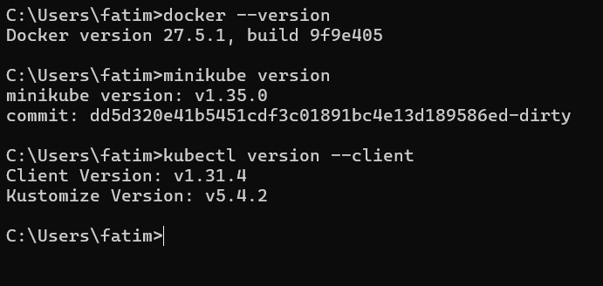

Installing all dependencies:  
npm install:  
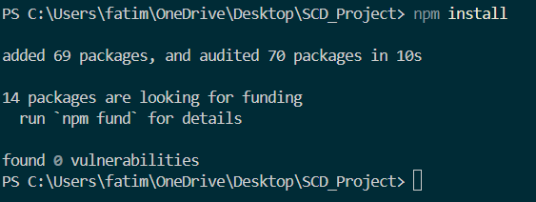

npm start:  
  
localhost:3000:

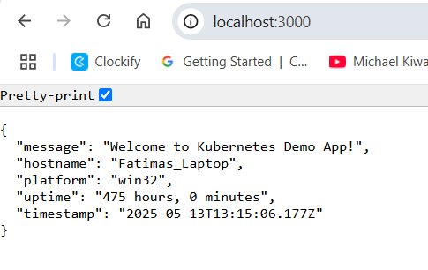  
  
Docker:  
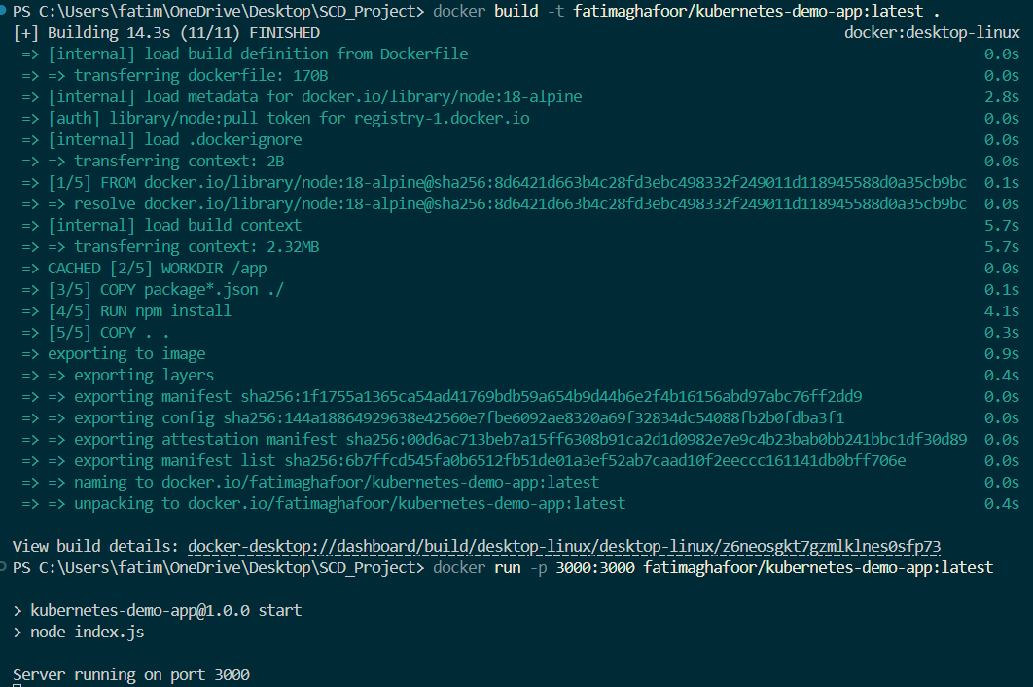

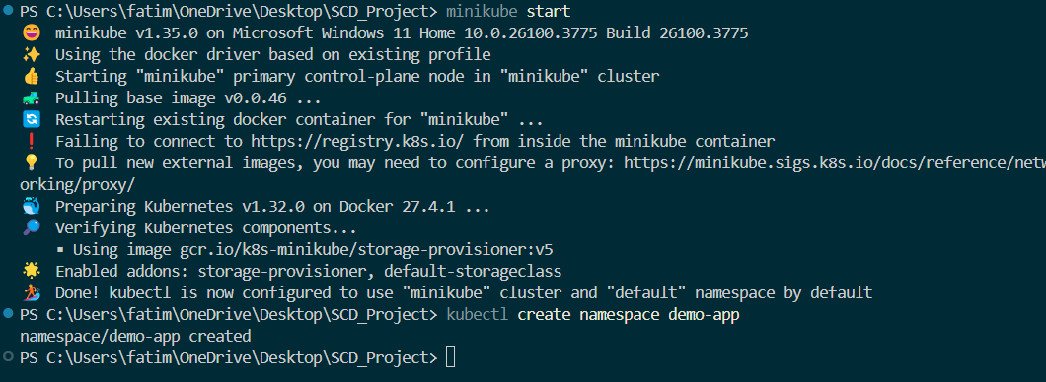

Applying manifest:

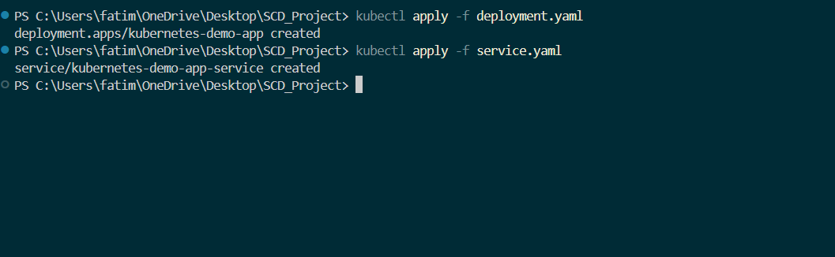  
  
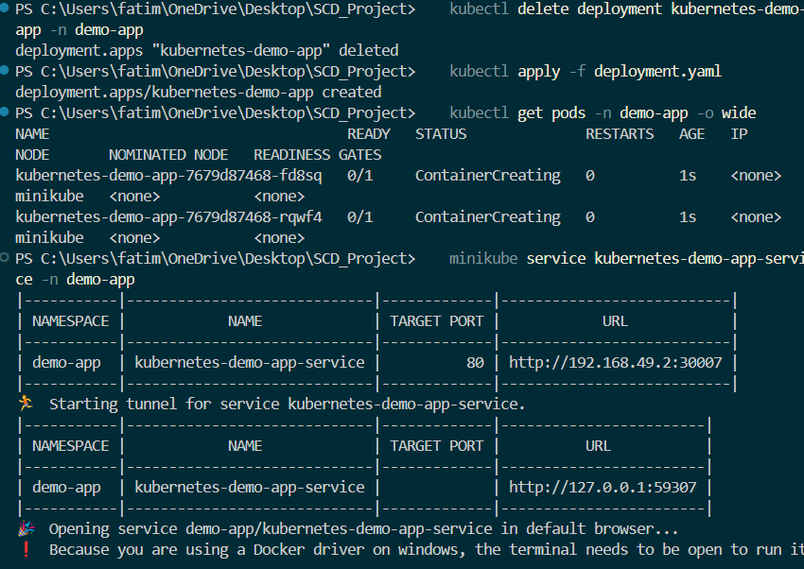  
  
Setting up git repo:  
